Tatevik Azoyan
August 16, 2024

Executive Summary

Feature Name | PDF markup
Product Area | Browser Extension. (Note that this feature can be implemented after file upload functionality from the website).
User Persona/ Story | All Haibrid Users (Focus on research, media, academia).  As a user, I want to be able to make highlights and notes on the PDFs and later review and share them with my teammates in the quickest and most user-friendly way possible.
Description | Overview  PDF markup functionality will enable Haibrid users to analyze and memorize content better by leaving notes for future recall, leading to more efficient organization of information and knowledge sharing.  Key Features  - Making highlights on PDFs that are uploaded on Haibrid source card  - Timestamped annotations from previous sessions  - Collaboration functions (?)  - Showing highlights and annotations on PDFs that are not uploaded to Haibrid, (if their names remain unchanged) (We can move it to Out of scope if it’s technically difficult to implement - discuss with the dev team)  - Redirecting to highlighted parts in the PDF
User Problem | PDFs are a major source of information for researchers, people working in media, education, and nearly all users that may find Haibrid a useful tool for their work. However, merely uploading PDFs without making highlights/notes and sharing with collaborators is not enough. This feature, along with redirecting to the highlighted part id has been mentioned as a wishlist item by a lot of people during user calls. For example, Levon Sevunts mentioned he “Would like to be able to share annotated pdfs indicating what was useful within the pdfs”.
Value Proposition | - Time saving: Streamlined PDF document review process  - Enhanced productivity and facilitated collaboration  - Reduced misunderstandings because of precise comments  - Secured sharing options  - Improved communication, easier knowledge and opinion sharing
Objectives | - Incentivize users to use Haibrid more often by addressing the need to incorporate PDF files into work.  - Increasing extension’s appeal as a separate product.
Assumptions | Users may not add some pdf s to Haibrid but want to make notes on it.
MVP | - Highlighting  - Showing/hiding highlights  - Adding notes (should we allow unlimited notes per highlight  - Editing Notes  - Deleting highlights and Notes  - Redirecting to highlighted sections
Out of Scope | - User mentioning functionality with email notifications (separate feature)  - Sending PDFs for review through invite links (need to validate if it’s useful)  - Adding URL connections (ability to attach links to specific highlights/notes)  - Quick copy of highlight  - Ability to work on the same pdf simultaneously
KPIs
Requirements | - PDF markup should be accessed from sticky notes via separate button/icon OR when pdf is opened and users click on the extension (but in this case, they would not be able to use general extension functionality while PDF is opened (TBD with dev team and Nelli how the markup should be opened?)  - There should be a floating toolbar when users select a text within a pdf, allowing to quickly make a highlight and note (if needed).  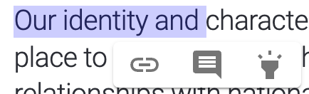  Hylinker  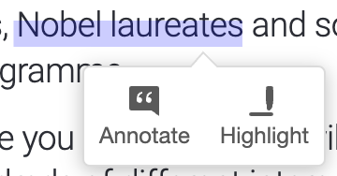  Hypothes.is  - Need to indicate who added a note and when (no need to show if it’s a highlight only )  - Notes should be by default sorted by recency, with the most recently added on top.  - PDF markup should have the same UI for the docs that are uploaded to Haibrid and the ones that are opened from the PC, with the only difference that PDF cannot be shared/collaborated on if it’s not uploaded on Haibrid  - Users should be able to add notes separately after they made a highlight (Basic text input only)  - Need to make tooltips on each icon and placeholders for inputs to instruct users  - Clicking on a note should redirect users to the highlighted text (can also change the color of highlighted text, like in Hylinker)  - The ability to view/add/edit highlights in a collaborative project should depend on the user permissions (viewer vs. editor) – TBD technical difficulty  - No need to lock the PDF when one of the collaborators has opened it or have PDF versions  Should we add search functionality for PDF highlights (or have it out of scope? And use default browser search?)  TBD with dev team
Competitor /Market Research | Market Overview  Competitive Analysis  Looked at Hylinker and Hypothes.is for inspiration  Need to make sure Access to file URLs is turned on  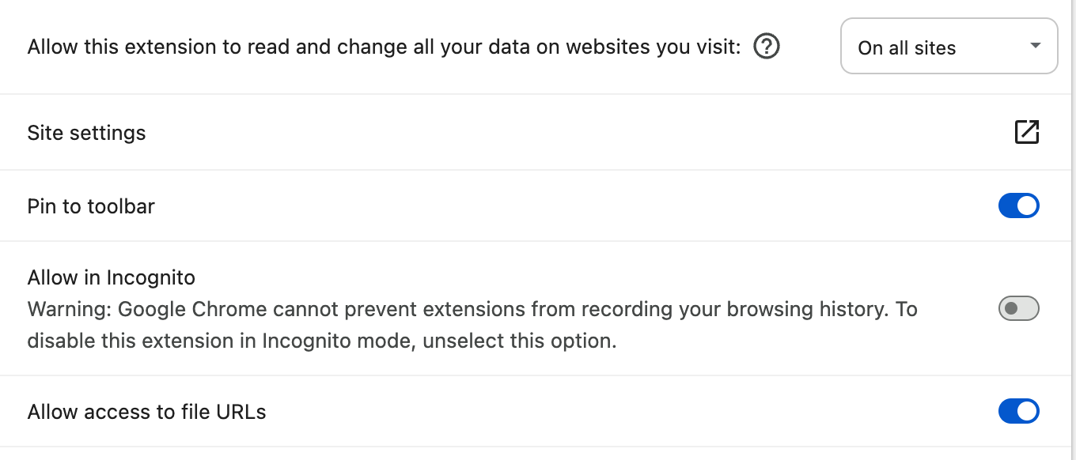  Market Trends  pdf element
High-level Mock Ups |   Hylinker – Hovering on the annotation changes the highlight’s color, clicking on it redirects to the highlighted text within PDF.  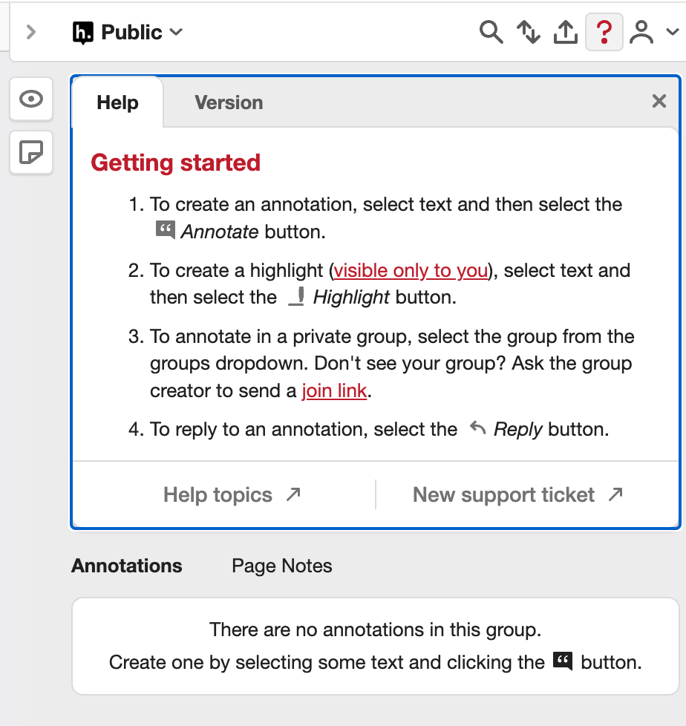  Hypothes.is – Sample instructions on how to use pdf annotations

